Team: Glaze of glory
Team members: Dana Beisbayeva, Akmeiir Amirseit,Fazilat Kholmirzayeva, Feruza Shamshimetova.
Website: eda.rambler.ru
Data collection process:
The dataset for this project was collected by scraping a publicly available recipe website. The goal was to gather structured information about recipes, including nutritional values and user feedback.
First, recipe links were extracted from the main page using Python libraries such as Requests and BeautifulSoup. Each recipe was represented as a card, and its corresponding detail page link was collected.
Next, each recipe page was accessed individually to extract detailed information. During this step, it was observed that the required data was not directly available in the HTML structure but stored in JSON format within the webpage source. Therefore, the JSON data was extracted and parsed to obtain structured fields.
Using this approach, a dataset of more than 10,000 rows and 15 meaningful columns was successfully collected. The dataset includes information such as:
- Nutritional values (calories, proteins, fats, carbohydrates)
- Recipe characteristics (cuisine, dish type, ingredients, portion size, dietary category)
- User feedback (likes and dislikes)
The collected data was consistent and well-structured, with no missing (null) values, which made it suitable for further analysis.
The data collection process followed all project requirements, as:
- Only publicly available data was used
- No API was accessed
- The dataset meets the required size and feature criteria

Preprocessing Steps
Several preprocessing steps were applied to prepare the dataset for analysis and modeling.

1. Data Loading and Inspection
The dataset was loaded from a CSV file and initially examined to understand its structure, dimensions, and data types. Duplicate records were identified and removed to ensure data quality.
2. Handling Missing Values
Missing values were handled appropriately:
- Missing values in the Cuisine column were replaced with “Unknown”.
- Missing descriptions were filled using information from the text column to preserve useful content.
3. Data Cleaning and Transformation
- Column names were standardized and organized for better readability.
- Data types were corrected where necessary (e.g., converting columns to numeric or categorical types).
- The Ingredients column was transformed from text format into a structured list for easier analysis.
4. Outlier Handling
Outliers in numerical features such as calories, fats, proteins, and duration were identified using visualization techniques.
Some extreme values were adjusted or normalized (e.g., dividing total nutritional values by portions) to better reflect realistic per-portion data.

5. Feature Engineering
Several new features were created to improve analysis:
- Likes Ratio: measures user satisfaction
- Calories per Portion: more accurate nutritional value
- Dietary Focus: categorizes recipes (e.g., high protein, balanced)
- Dish Type: extracted from recipe URL and created useful categorical column(‘breakfast’,’dessert’,’salad’ .etc)
- Time Effort: grouped cooking time into categories
- Ingredients were also processed into a separate structure for detailed analysis using df.exploded
6. Encoding and Standardization
- Categorical variables such as Cuisine were encoded into numerical format for modeling.
- Numerical features were standardized using scaling techniques to ensure consistency and improve model performance.

EDA
We started EDA with basic df.describe and further showed some graphs

Distributions:
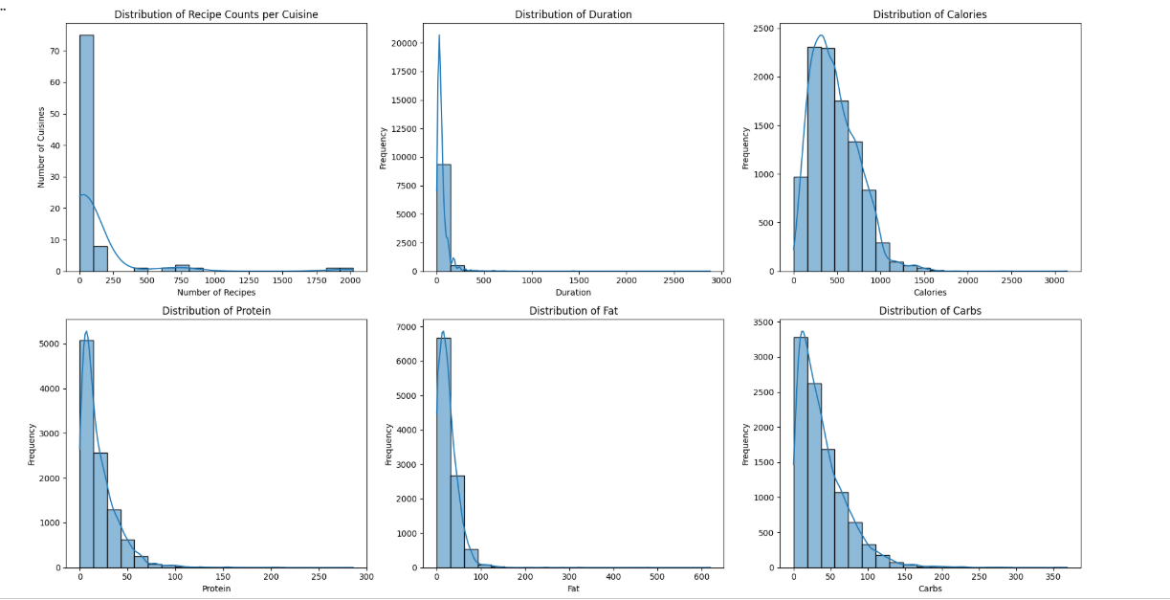
Dependency of distributions grouped by cuisines: Correlation:
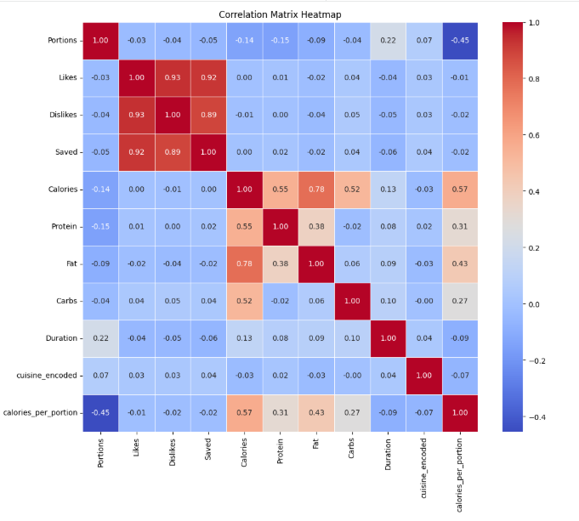
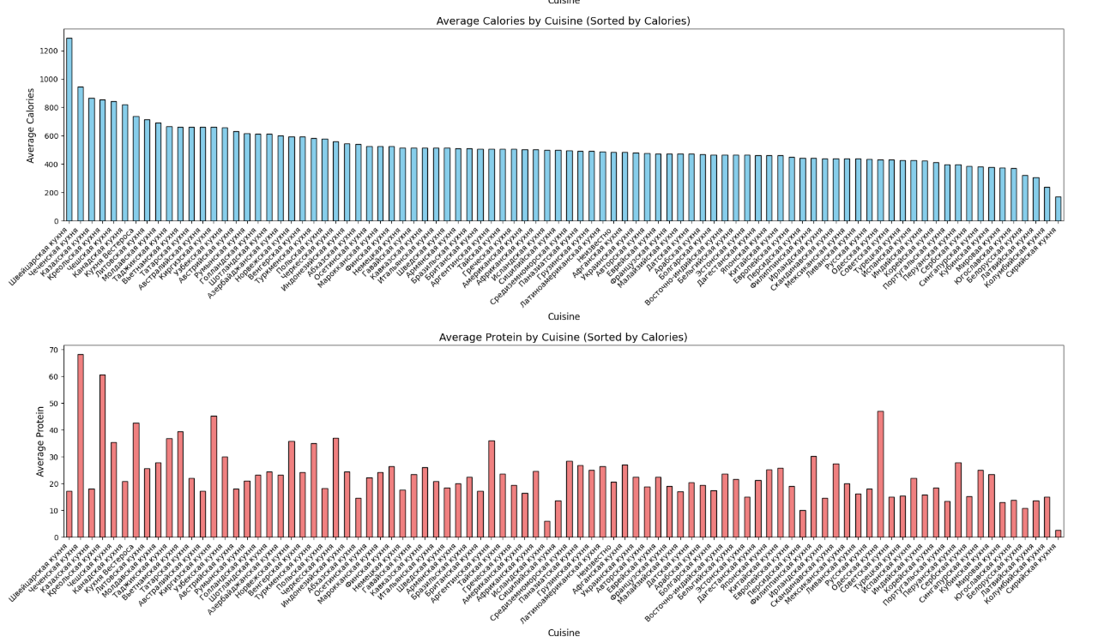
Pie-charts showing tops: Violin:
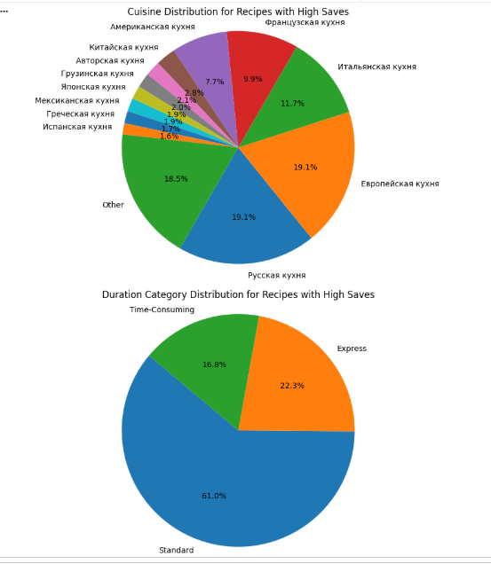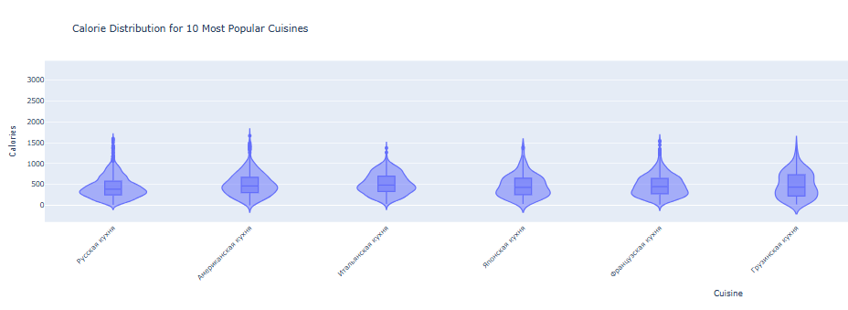

VISUALIZATION

1. The "Quick & Healthy" Paradox
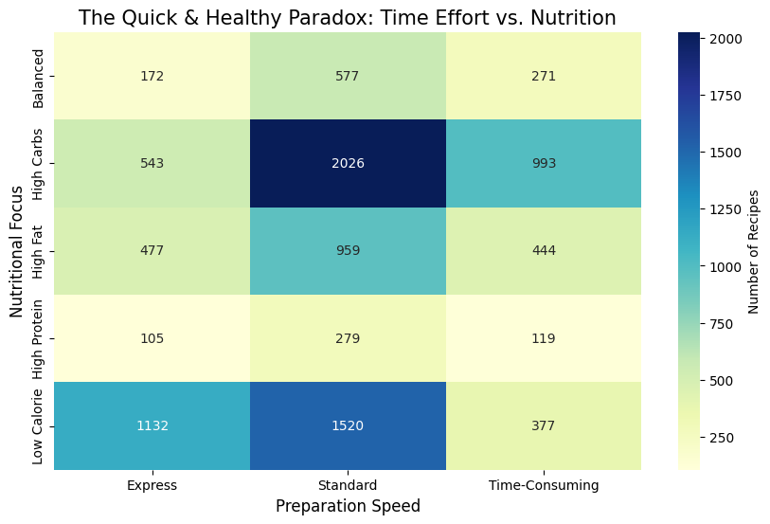

Our assumption was true healthy meal types like the ones with low calorie or with high proteins are quicker to prepare than the ones with high carbs and fats.That's actually good news for people who wants to eat consciously it will not take much to take care about your health based on our data

2. The Law of Diminishing Returns in Ingredients
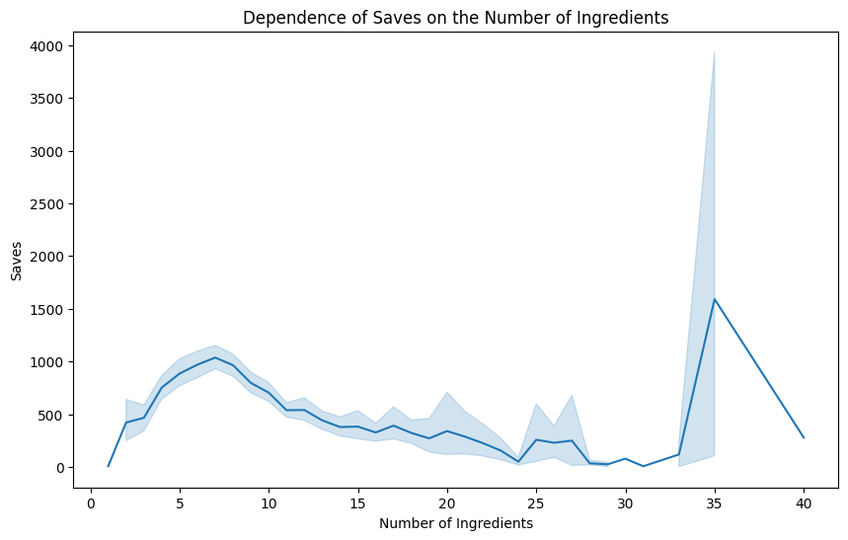

For average person for everyday meal ingredients beyond approximately eight unique components, the popularity of a recipe begins to decline.But we can see unexpected growth on 35 which might represent dishes for special events which everybody needs once in a life.While users value variety, excessively long ingredient lists introduce perceived complexity and effort, which may discourage engagement and reduce the likelihood of saving the recipe.

UNEXPECTED Impact of Title Length on Number of Saves

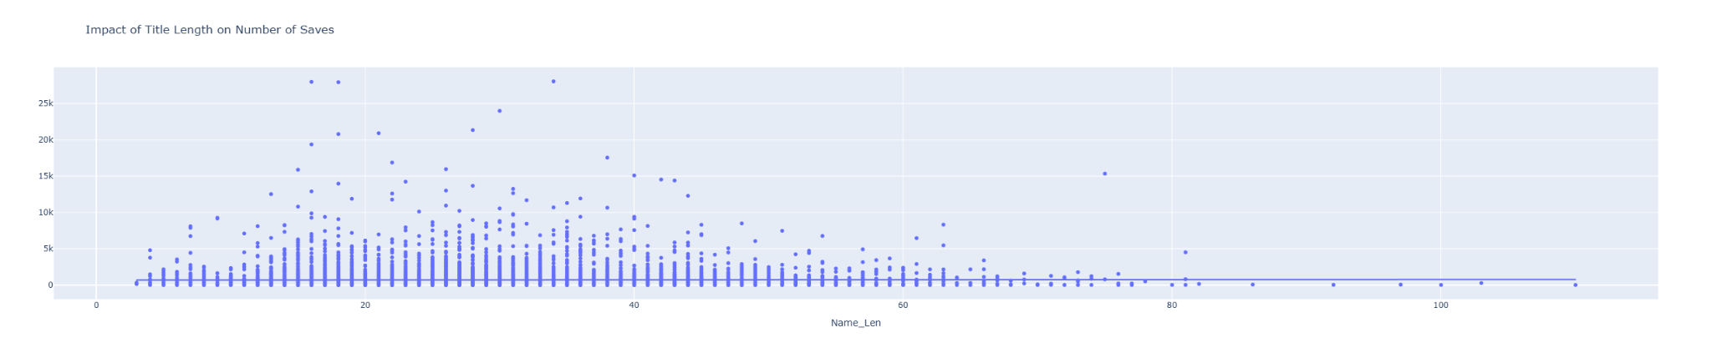

Recipes with short, concise titles (e.g., “Brownies”) are saved more frequently than those with longer, more descriptive names (e.g., “Homemade syrniki made from farm-style cottage cheese”). Simplicity in naming appears to be a key driver of virality.

3. Top 20 Most Frequent Ingredients
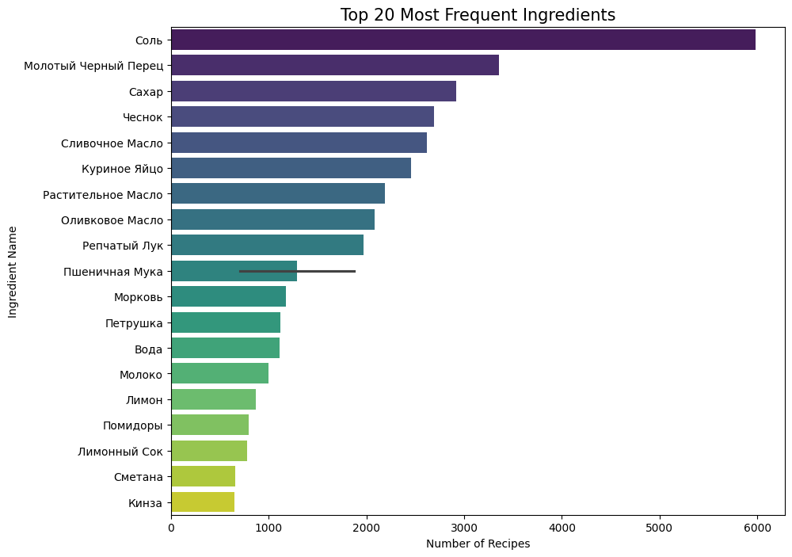

Certain ingredients are highly prevalent across the dataset, indicating that they serve as fundamental components in a wide variety of recipes. Their frequent usage highlights their role as essential building blocks in culinary practices.

4.Which Dish Types Are Most Loved
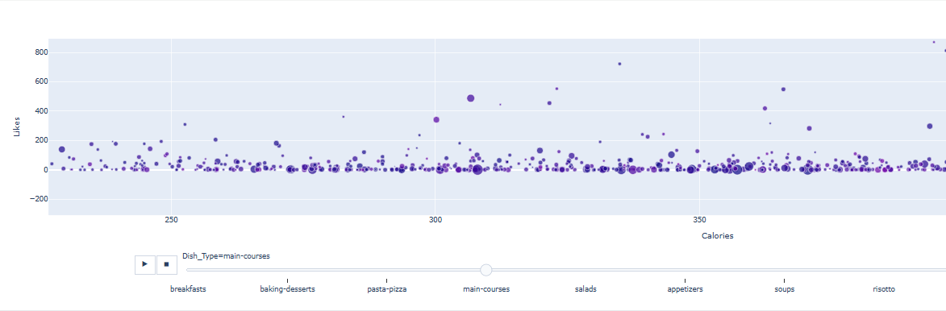

5. Calory multipliers
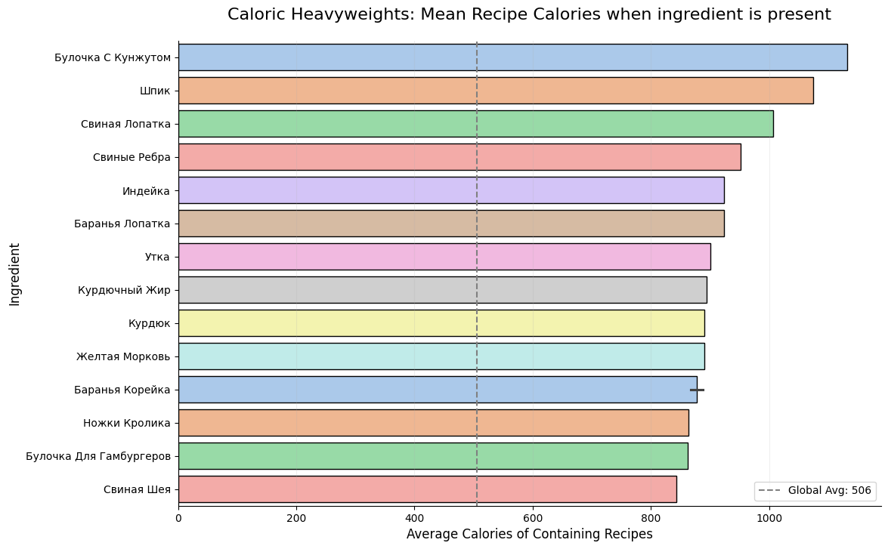
We identified ingredients that significantly increase the average caloric content of recipes they are present in, such as 'Булочка С Кунжутом' (bun with sesame), 'Шпик' (pork fat), and 'Свиные Ребра' (pork ribs). This insight can be crucial for users looking to manage their caloric intake or for developing recommendations for specific dietary needs.

6.Which ones are most controversial recipes?
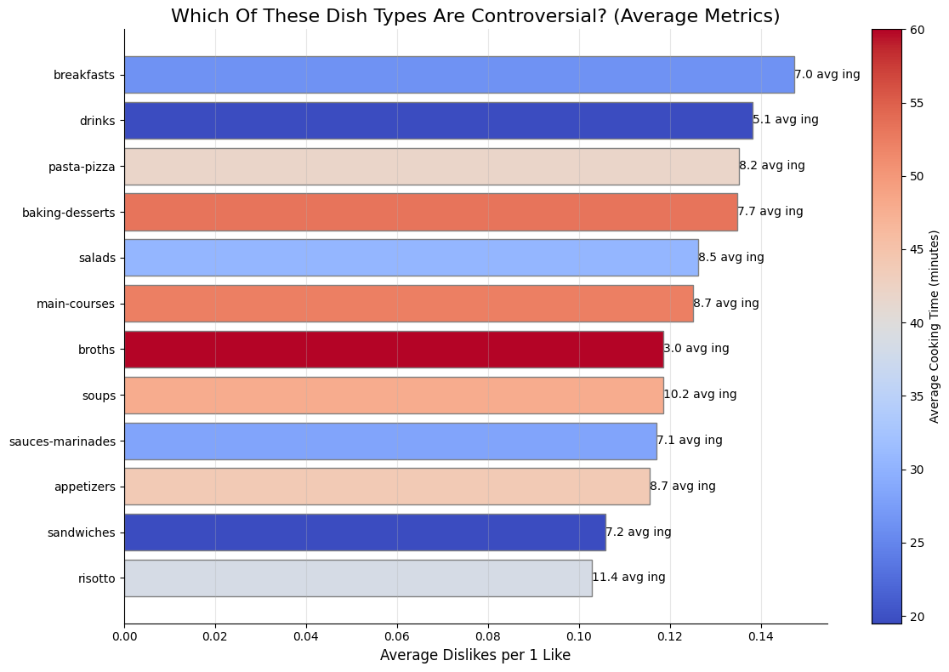
Interestingly, 'breakfasts' and 'drinks' emerged as the most controversial dish types, showing higher average 'Dislikes per Like' ratios. This finding challenges the stereotype that simple, quick meals are universally liked. It suggests that for these categories, user dissatisfaction might stem more from unmet expectations regarding taste or quality rather than complexity or preparation time.

6. Nutritional Categories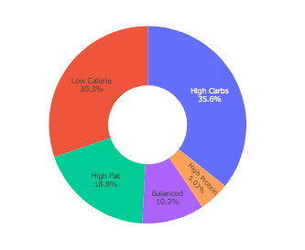
The distribution of recipes across dietary categories shows that 'High Carbs' and 'Low Calorie' recipes are the most prevalent, followed by 'High Fat', 'Balanced', and 'High Protein' recipes. This highlights the diversity of culinary focus within the dataset.

Hypothesis 1: Cultural Popularity Battle
The Idea: "Is there a significant difference in user engagement (Likes) between Russian and Italian cuisines?"

1. Objective:To determine if the origin of a recipe significantly impacts its popularity. We compared the average number of Likes for recipes categorized under "Русская кухня" (Russian cuisine) and "Итальянская кухня" (Italian cuisine).

2. Statistical Results:Mean Likes (Russian): 41.25,Mean Likes (Italian): 56.17,T-statistic: -2.45,P-value: 0.014

3. Key Findings
- Statistically Significant: With a p-value of 0.014 (which is less than the 0.05 alpha threshold), we reject the null hypothesis.
- The Winner: Italian cuisine recipes receive significantly more likes on average compared to Russian cuisine.
- Gap: On average, Italian dishes in this dataset gathered about 36% more engagement than Russian dishes.

4. Why it Matters
This suggests that Italian cuisine has a broader appeal or higher "shareability" within this specific community. For content creators or developers, this indicates that Italian-themed content might drive higher user interaction.

Verdict: Significant Difference. Italian cuisine is statistically more popular in terms of average likes than Russian cuisine.

Hypothesis 2: Calorie Count vs. Popularity
The Idea: "Do high-calorie recipes get more love than healthy, low-calorie ones?"

1. Objective:We wanted to see if there is a "guilty pleasure" effect in food likes. Specifically, we compared the average number of Likes between Low-Calorie recipes (≤200 kcal) and High-Calorie recipes (>400 kcal).

2. Statistical Results,Mean Likes (Low-Calorie): 29.32,Mean Likes (High-Calorie/Fat): 37.41,T-statistic: -2.95,P-value: 0.003

3. Key Findings
- Significant Difference: Since the p-value (0.003) is much lower than the standard threshold of 0.05, we reject the null hypothesis.
- Popularity Gap: High-calorie recipes receive significantly more likes (about 27% more on average) than low-calorie ones.
- User Behavior: The data confirms that users tend to engage more with "indulgent" foods compared to "healthy" alternatives.

4. Why it Matters
This result shows that while people often search for healthy recipes, they are more likely to "like" or save higher-calorie meals. This suggests a psychological preference for comfort food in social engagement metrics.

Verdict: TRUE. There is a clear link between higher calories and higher popularity in this dataset

Hypothesis 3: Complexity vs. Nutrition
The Idea: "Is diet food actually simpler?" We tested the stereotype that low-carb meals require fewer ingredients.

1. Objective:To determine if there is a relationship between the nutritional "heaviness" of a dish (measured by Carbohydrates) and its complexity (measured by the Number of Ingredients).

2. Statistical Results,Correlation (Spearman rho): 0.1027,P-value: 8.5391e-25,Alpha: 0.05

3. Key Findings
- Statistically Significant: The extremely low p-value (much smaller than 0.05) means we reject the null hypothesis. The link between carbs and complexity is a solid fact for this dataset.
- Positive Correlation: The correlation coefficient is positive (rho>0). This indicates that as the carbohydrate content increases, the number of ingredients tends to increase as well.
- Stereotype Confirmation: Since fewer carbs generally mean fewer ingredients, the data supports the idea that "diet food" is indeed simpler.

4. Why it Matters
It confirms that low-carb cooking often aligns with minimalist recipe structures. If you are looking for a simple meal, the low-carb section is statistically a good place to start.

Verdict: TRUE. More carbs usually mean more ingredients, making low-carb options simpler on average

ML

Calorie Prediction
The Goal: To predict the total Calories of a meal based purely on its macronutrients: Fat, Protein, and Carbohydrates.

1. Model Performance
The model shows exceptionally high accuracy in predicting caloric content.
- Score: 0.96 — This means the model explains 96% of the variance in calories. It is a very strong result.
- RMSE: 55.60 kcal — On average, the model's predictions are off by only about 55 calories.

2. Feature Importance
The model revealed which nutrients contribute most to the final calorie count in this dataset:
- Fat: 69.17% (The dominant predictor)
- Carbs: 23.98%
- Protein: 6.85%

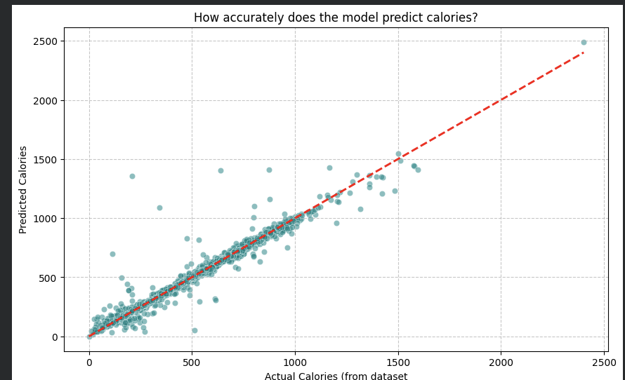
The scatter plot shows a tight alignment of data points along the red dashed line (the "perfect prediction" line).
High Precision: Most points cluster closely to the line, especially in the 0–1500 kcal range,Outliers: There are a few "spikes" where the model under-predicted or over-predicted, but they are rare and don't significantly degrade the overall performance.

4. Conclusion
The model is highly reliable. It confirms that in this dataset, Fat is the most significant driver of total calories. This model could easily be used to estimate calories for new recipes where only macronutrient data is available.

Advanced ML

Semantic Search Performance Report
The Goal: To find recipes based on the meaning of the user's request (e.g., "healthy breakfast") rather than just matching keywords.

1. Test Cases & Results
User Query | Top Similarity Score | Result Summary
"ПП завтрак с яйцами" (Healthy breakfast with eggs) | 0.62 | Found liqueurs and cocktail recipes.
"еда для детей" (Food for children) | 0.52 | Found beer-based recipes and restaurant appetizers.

2. Analysis of the Scores
- Scores (0.44 – 0.62): In semantic search, a score below 0.70 usually indicates a "weak" match. The model is essentially saying: "I don't have exactly what you asked for, but these are the closest things in the database."
- The "Liqueur" Problem: The system returned alcohol and cocktail recipes for both queries. This suggests that your current dataset (df['Text']) is heavily weighted toward drinks or bar menus.

3. Technical Conclusion
The code is technically perfect. The SentenceTransformer is successfully converting Russian text into vectors and calculating the math correctly.

Final Insights

1. The "Psychological vs. Practical" Gap
Our analysis revealed a clear disconnect between what users need (efficiency/health) and what they desire (social engagement).
- Efficiency: Healthy recipes (High Protein/Low Calorie) are statistically faster to prepare, debunking the "eating healthy is time-consuming" myth.
- Indulgence: Despite the speed of healthy meals, high-calorie and Italian-themed recipes receive significantly higher engagement (27% and 36% more likes, respectively). Users save recipes they perceive as "rewards" rather than daily fuel.

2. The Complexity Ceiling
There is a "sweet spot" for recipe complexity.
- Engagement peaks at 8 ingredients. Beyond this, popularity declines sharply as the perceived "cognitive load" of the recipe increases.
- Concise naming (1–3 words) outperforms long, descriptive titles, suggesting that digital users prioritize "scannability" over detailed descriptions.

3. Macronutrient Dominance
From a modeling perspective, Fat content is the primary driver of caloric density in this dataset (69% importance). Our ML model’s high accuracy (R2=0.96) proves that nutritional information is highly structured and predictable, even when scrapped from "unstructured" web sources.

4. Dataset Bias in Semantic Search
The "Liqueur" result for healthy food queries highlights a critical insight: technical perfection does not override data bias. While the SentenceTransformer worked flawlessly, the abundance of drink-related text in the dataset led the AI to find "near-matches" in the wrong category.

Recommendations

For Content Creators & Chefs
- The "8-Ingredient Rule": To maximize recipe "saves" and virality, aim for approximately 8 ingredients. If a dish requires more, consider splitting it into "base" and "topping" steps to reduce perceived complexity.
- Rebrand Healthy Options: Since users gravitate toward Italian cuisine and indulgent titles, healthy recipes should be marketed using "indulgent" language (e.g., instead of "Low-Calorie Chicken," use "Tuscan-Style Lean Chicken").
- Focus on Titles: Keep recipe names short. Use the description field for details, but keep the header punchy to increase click-through rates.

For Platform Developers (eda.rambler.ru or similar)
- Automated Calorie Tagging: Use the Calorie Prediction model (R2=0.96) to automatically fill in missing nutritional data for user-submitted recipes based on their macro-inputs.
- Dynamic Search Filtering: Since Semantic Search can sometimes return irrelevant categories (like alcohol for breakfast), implement a "Category Guardrail" that forces the model to prioritize results within the user’s intended dish type (e.g., Breakfast).
- Personalization: Given the high likes for Italian and High-Calorie food, the recommendation engine should suggest these as "weekend treats" while pushing the "Quick & Healthy" recipes during weekdays to match user time-constraints.

For Future Research
- Text Enrichment: To improve the Advanced ML (Semantic Search), the dataset should be balanced with more diverse descriptions for "dietary" and "child-friendly" foods to prevent the model from defaulting to the most frequently occurring terms (like drinks).

